GRIFFIN PRIMARY SCHOOL

Equality & Community Cohesion Policy

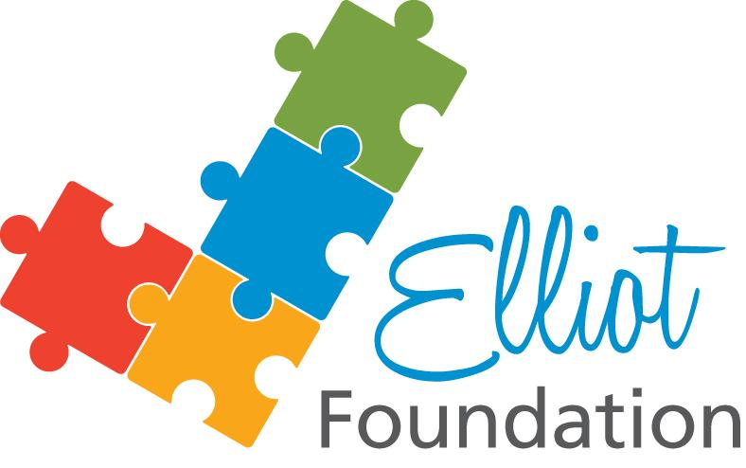


September 2018

Equality & Community Cohesion Policy

The Governing Body of Griffin School adopted this policy
on 1st April 2016

Griffin Primary School
Equality and Community Cohesion Policy

- Legal framework

We welcome our duties under the Disability Discrimination Acts 1995 and 2005; the Race Relations 1976 as amended by the Race Relations Amendment Act 2000; the Sex Discrimination Act 1975 as amended by the Equality Act 2006; and the expectation in the Equality Bill 2009 that we should promote equality, diversity and good relations in relation to age, faith and religion, gender reassignment and sexual and gender identity.

We welcome our duty under the Education and Inspections Act 2006 to promote community cohesion.

We welcome the proposals set out in Equality Bill: making it work, published by the Government Equalities Office in June 2009, that from 2011 onwards we should publish a statement of equality objectives for our school and should report on progress towards achieving them.

We recognise that these duties are essential for achieving the international human rights standards as expressed in the UN Convention on the Rights of the Child, the UN Convention on the Rights of People with Disabilities, and the Human Rights Act 1998.

Griffin joined The Elliot Foundation in April 2015 and actively supports the policies and practice of the Foundation, adhering to their philosophy and documents.

- Guiding principles
In fulfilling the legal obligations cited above, we are guided by seven principles:

Principle 1: All learners are of equal value

We see all learners and potential learners, and their parents/ carers, as of equal value,
- Whether or not they are disabled,
- Whatever their ethnicity, culture, religious affiliation, national origin or national status,
- Whatever their gender and gender identity,
- Whatever their sexual identity.

Principle 2: We recognise and respect difference

Treating people equally (Principle 1 above) does not necessarily involve treating them all the same. Our policies, procedures and activities must not discriminate but must nevertheless take account of differences of life-experience, outlook and background, and in the kinds of barrier and disadvantage which people may face, in relation to:

- Disability, so that reasonable adjustments are made;
- Ethnicity, so that different cultural backgrounds and experiences of prejudice are recognised;
- Gender, so that the different needs and experiences of girls and boys, and women and men, are recognised;
- Sexual identity.

Principle 3: We foster positive attitudes and relationships, and a shared sense of cohesion and belonging

We intend that our policies, procedures and activities should promote:
- Positive attitudes towards disabled people, good relations between disabled and nondisabled people, and an absence of harassment of disabled people;
- Positive interaction, good relations and dialogue between groups and communities different from each other in terms of ethnicity, culture, religious affiliation, national origin or national status, and an absence of prejudice-related bullying and incidents;
- Mutual respect and good relations between boys and girls, women and men, people of varying sexual identities, and an absence of sexual and homophobic harassment.

Principle 4: We observe good equalities practice in staff recruitment, retention and development, and student admissions and pathways.

We ensure that policies and procedures should benefit all employees and potential employees, for example in recruitment and promotion, and in continuing professional development,
- Whether or not they are disabled,
- Whatever their ethnicity, culture, religious affiliation, national origin or national status,
- Whatever their gender and sexual identity, and with full respect for legal rights relating to pregnancy and maternity/paternity.

Principle 5: We aim to reduce and remove inequalities and barriers that already exist

In addition to avoiding or minimising possible negative impacts of our policies, we take opportunities to maximise positive impacts by reducing and removing inequalities and barriers that may already exist between:
- Disabled and nondisabled people
- People of different ethnic, cultural and religious backgrounds
- Girls and boys, women and men.

Principle 6: We consult and involve widely

People affected by a policy or activity should be consulted and involved in the design of new policies, and in the review of existing ones. We consult and involve
- Disabled people as well as nondisabled,
- People from a range of ethnic, cultural and religious backgrounds,
- Both women and men, and girls and boys,
- LGBT people as well as straight.

Principle 7: Society as a whole should benefit

We intend that our policies and activities should benefit society as a whole, both locally and nationally, by fostering greater social cohesion, and greater participation in public life of
- Disabled people as well as nondisabled,
- People of a wide range of ethnic, cultural and religious backgrounds,
- Both women and men, girls and boys,
- LGBT people as well as straight.

- The Griffin Inside Out Learning Model.

We keep our holistic learning model and learning areas under review in order to ensure that teaching and learning reflect the seven principles set out above.

- Ethos and organisation

- We ensure the principles listed in paragraph 5 above apply to the full range of our policies and practices, including those that are concerned with:
- Teaching, learning and behaviour
- Students’ personal development, welfare and well-being
- Inclusion
- Admissions and attendance
- Staff recruitment, retention and professional development
- Care, guidance and support
- Working in partnership with parents and carers
- Working with the wider community

- Addressing prejudice and prejudice-related bullying

Griffin is opposed to all forms of prejudice, which stand in the way of fulfilling the legal duties:
- Prejudices around disability and special educational needs
- Prejudices around racism and xenophobia, including those that are directed towards religious groups & communities, for example anti-Semitism & Islamophobia & those that are directed against Travellers, migrants, refugees & people seeking asylum
- Prejudices reflecting sexism and homophobia

There is guidance later in this document on how prejudice-related incidents should be identified, recorded and dealt with.

We take seriously our obligation to report regularly to the local authority about the numbers, types and seriousness of prejudice-related incidents at Griffin and how they are dealt with.

- Roles and responsibilities

The Local Governing Body will:
- Ensure that Griffin complies with legislation, including the general and specific duties.
- Ensure that the policy and its related procedures and strategies are implemented.
- Identify a governor with lead responsibility for equality.

The Executive Head will:
- Work in partnership with the Local Governing Body to ensure that the policy and related procedures and strategies are successfully implemented.
- Ensure that all staff are aware of their responsibilities under the policy and are given appropriate training and support so that they can fulfil their responsibilities.
- Treat seriously all incidents of discrimination and prejudice-related bullying and take appropriate action.
- Ensure that additional grants and resources are appropriately targeted and monitored.
- Identify a member of staff responsible for co-ordinating the implementation of the policy.

Leadership Group members will:
- Monitor patterns of achievement within their Teams, identify any patterns of underperformance and lead their teams in targeting interventions; this process will be reported officially to the Executive Head in Data Capture Review meetings.
- Be responsible for reviewing and monitoring curriculum policies and planning in their own Lead areas to ensure that race equality is promoted.

All staff will:
- Promote an inclusive and collaborative ethos in their classroom.
- Deal with any prejudice-related incidents that may occur.
- Plan and deliver curricula and lessons that reflect the guiding principles in section B above.
- Support students in their class for whom English is an additional language.
- Keep up-to-date with equalities legislation relevant to their work.

Visitors and contractors will:
- Be aware of and comply with the Griffin’s equality policy.
Gf. Monitoring the impact of the Equality Policy
Students
To monitor our students' attainment, we collect information about student performance and progress, by ethnic group, gender, SEN and disability and analyze and use it to examine trends. A detailed ethnic breakdown of attainment and progress data is carried out annually, and at each Data Capture period. To help interpret this information, we also monitor other areas, such as:
- Behaviour and exclusion;
- Racism, racial harassment and bullying;
- Attendance
- Parental involvement;

Monitoring information will help us to see what progress we are making towards meeting our race equality targets and aims.

In particular it will help us to:
- Highlight any differences between students from different groups;
- Ask why these differences exist and test the explanations given;
- Review the effectiveness of current targets and objectives;
- Decide what further action will be necessary to meet particular needs and to improve the performance of students from different groups;
- Re-think and set targets in relevant strategic plans;
- Make links with performance management objectives which will include information about quality as well as quantity;
- Take action to make improvements.

Staff/ Community
We monitor staff appointments and professional development, and also the composition of the Local Governing Body.

This monitoring information will be published to Governors, who will use it to evaluate and review the effectiveness of the Race Equality Policy. It will also form part of the Self Evaluation Form and will be used to inform the annual cycle of School Improvement Planning.

The Local Governing Body will review the implementation of the policy regularly and review annually.

- Information and resources

We ensure that the content of this policy is known to all staff and governors and, as appropriate, to all students and their parents/ carers.

All staff and governors have access to a selection of resources, which discuss and explain concepts of equality, diversity and community cohesion in appropriate detail.

- Religious observance

We respect the religious perspectives of all staff; students, parents/ carers – believers and non- believers - and we comply with reasonable requests relating to religious observance and practice.

- Staff development and training

We ensure that all staff, including support and administrative staff, receives appropriate training and opportunities for professional development, both as individuals and as groups or teams.

- Breaches of the policy

Breaches of this policy will be dealt with in the same ways that breaches of other Griffin policies are dealt with, as determined by the Executive Head and Local Governing Body.

Appendix 1:

Assessing the impact of other policies

There is a rolling programme of reviewing key Griffin policies. As a part of each policy review, there will be an assessment of its impact on equality by considering the following questions as part of the review:
  - What evidence is there (quantitative – data on exclusions, attainment, attendance etc, and qualitative – student and parent/ carer questionnaires, focus groups, conversations with stakeholders, record of complaints etc) that this policy does not have an adverse impact on students, parents/ carers or staff from some groups?
  - How do we explain any differences in the impact of this policy on different groups? Are the explanations justified? Can they be justified on other grounds?
  - Does this policy include aims to address differential performance between groups? Do our policies lead to action to deal with differences, which have been identified (for example, extra coaching for students, or steps to prevent bullying)?
  - What are we doing to raise standards and promote equality of opportunity for students who seem to be underachieving and who may need extra support?
  - How does this policy promote equality and harmony and prevent or deal with prejudice and discrimination?
  - Is the action taken as a result of this policy appropriate and effective? Are there any unexpected results? If so, how are they being handled?
  - Does this policy include aims to promote equality and harmony, prevent or challenge discrimination, and deal with differences (or possible/perceived differences) between different groups?
  - Does the policy's aims lead to effective action?
  - What changes do we need to make to this policy to promote equality and equality of opportunity and to challenge discrimination?

Appendix 2:

Action to be taken when prejudice-related bullying or harassment is suspected or reported

- Talk to the target, the perpetrator, and any witnesses. If the target defines the incident as racist, sexist or homophobic, or on grounds of disability, investigate it with this in mind.

If any degree of bullying or harassment is identified, the following action will be taken:

2. Both parties and any witnesses should write statements, which should be signed and dated.

3. Help, support and counselling will be given as appropriate to both the target and the perpetrator

4. We support the target in the following ways:

- Ensure the young person is made to feel valued and is actively listened to.
- Offer an opportunity to talk about the experience with an adult.
- On the same day, inform the target’s parents/carers of the incident and that Griffin response to that incident.
- In consultation with the student’s class teacher, offer continuing support to the target e.g. counselling mentor support, community group support, circle time, social skills training, peer support.
- Arrange for the student to be escorted to and from Griffin if necessary.
- Take one or more of the disciplinary steps described below to prevent more bullying.
- If necessary, we will inform the police of the incident.

5. We discipline and support the perpetrator in the following ways:

- Discuss the incident to discover any underlying issues.
- Explain why the behaviour was unacceptable and implement appropriate consequences as outlined below:
- Inform the perpetrator’s parents/ carers and invite them to work with Griffin, to ensure that their child does not re-offend.
- Fixed term exclusion, internal exclusion, on report, detention, mentor support, counselling, Intervention Plan, peer support, or referral to appropriate outside agencies.
- Where necessary we will contact the police.
- Incidents of racial harassment will be reported to The Elliot Foundation and, where appropriate, to Hammersmith & Fulham LA.

